Height and Width in CSS are used to set the height and width of boxes. It’s value can be set using length, percentage or auto.

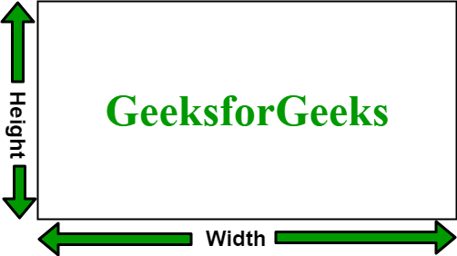

**Example:**

<style>

         .GFG{

         height: 120px;

         width: 50%;

         border: 5px solid black;

         padding-left: 50px;

         padding-top: 50px;

         font-size:42px;

         font-weight:bold;

         color:green;

         margin-left:50px;

         margin-top:50px;

         }

      </style>

**Height and width of Image:** It is used to set the height and width of an image. It’s value can be in px, cm, percent, … etc.

  <style>

         .GFG {

         width:300px;

         height:200px;

         border:3px solid black;

         }

      </style>

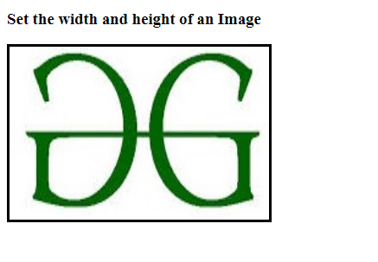

**Set max-width and min-width of an element:** 

* **max-width:** It is used to set the maximum width of the box. It’s effect can be seen by resizing the browsers.
* <style>
* .GFG {
* max-width:500px;
* border:2px solid black;
* }
* </style>

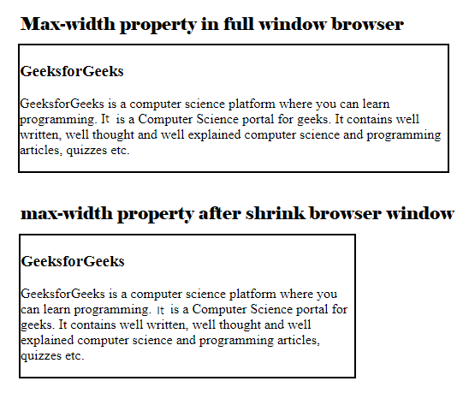

**min-width:** It is used to set the minimum width of the box. It’s effect can be seen by resizing the browsers.   
**Example:**

<style>

         .GFG {

         min-width:400px;

         border:2px solid black;

         }

      </style>

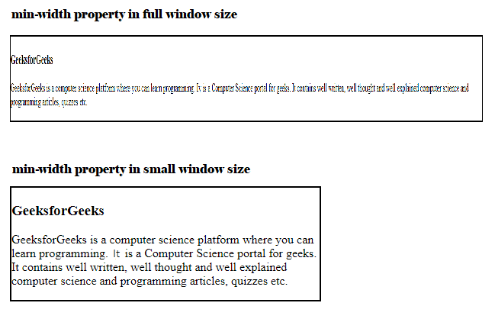

**max-height:** It is used to set the maximum height of the box. It’s effect can be seen by resizing the browsers.   
**Example:**

<style>

         .GFG {

         max-height:100px;

         border:2px solid black;

         }

      </style>

* 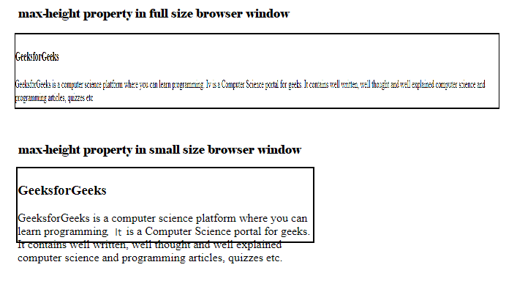**min-height:** It is used to set the minimum height of the box. It’s effect can be seen by resizing the browsers.   
  **Example:**
* <style>
* .GFG {
* min-height:50px;
* border:2px solid black;
* }
* </style>

